1. If you are loading both ETCs and Status, load ETCs first.
2. Prepare an Excel file for loading. You will need Control Account, OBS, Work Package and Percent Complete. Add two more columns and title them Actual Start Date and Actual Finish Date. Format the Percent Complete as a Number. Your file should be formatted like this:

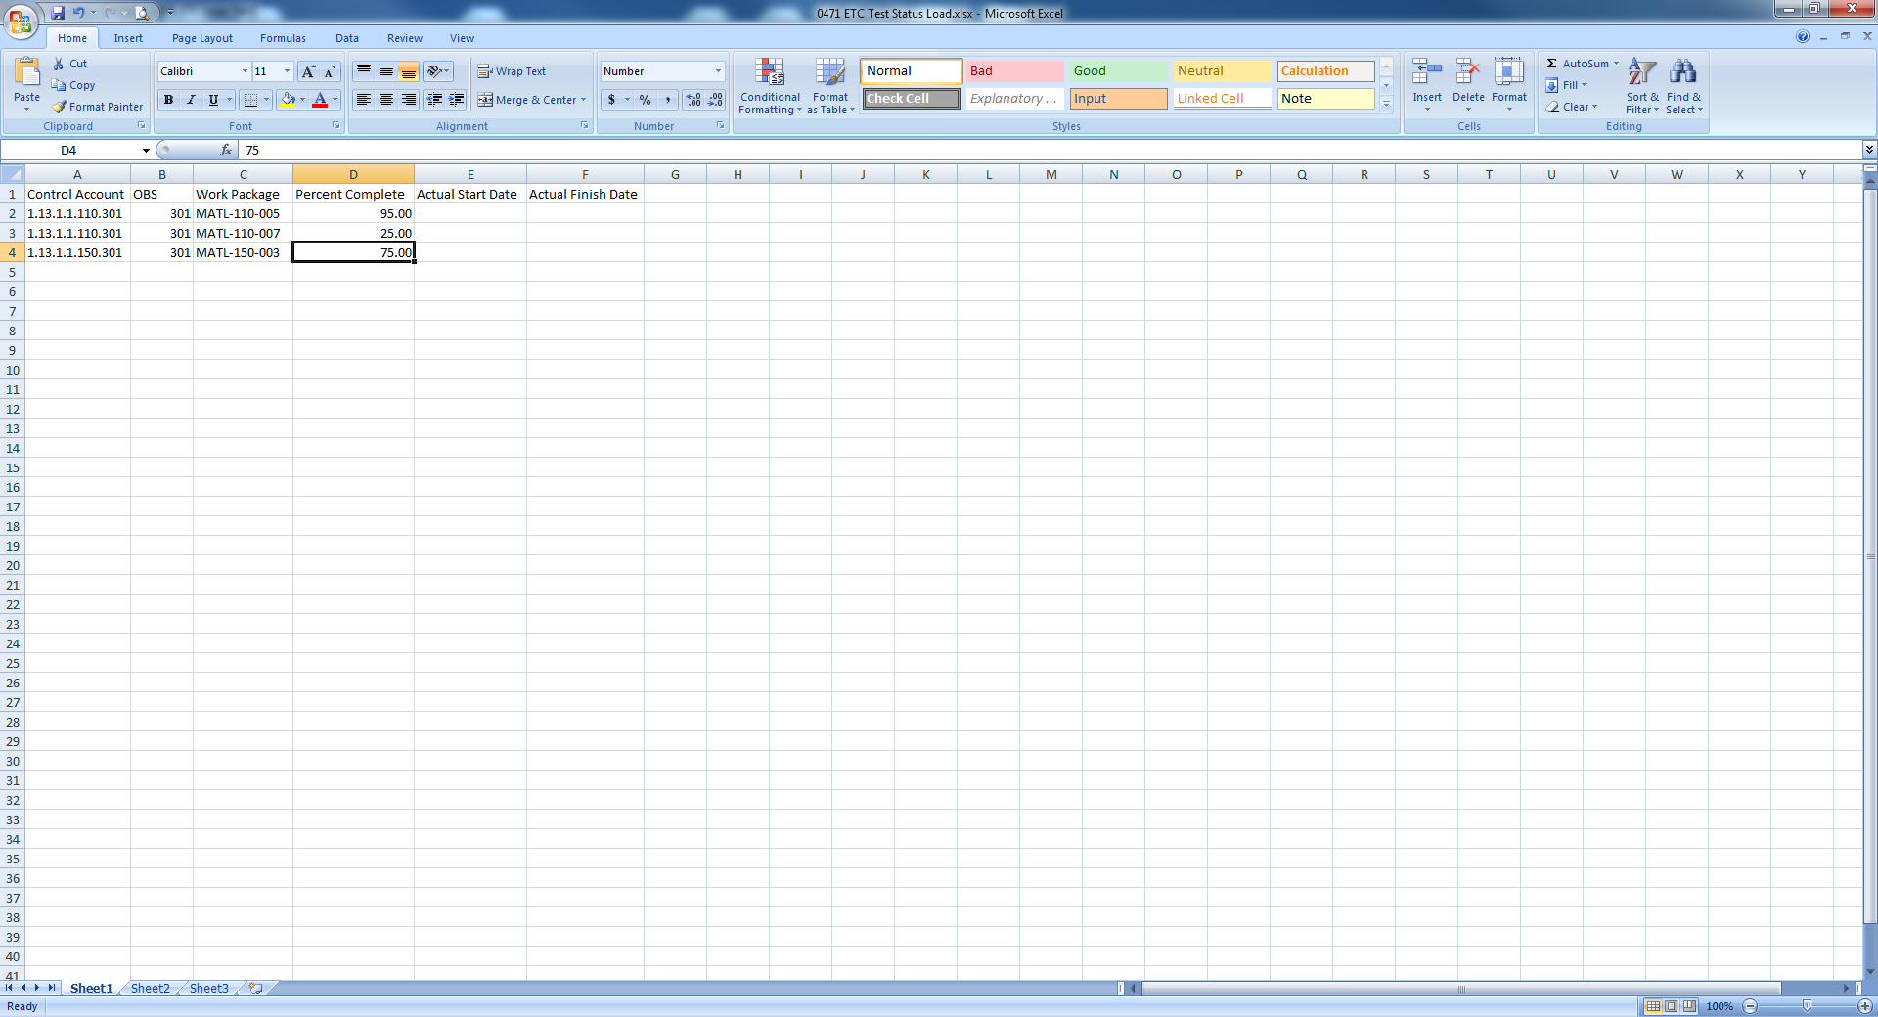

Call this file your **Status File**.

1. Open your program in Cobra and expand all. With your cursor in the column header on the CAWP Pane, right-click and select **Insert Column**. Click the dropdown for Field Name and select **Actual Start**. Do the same again to insert to **Actual Finish**. Both are placed as the last columns. Drag both columns to right after the WP.

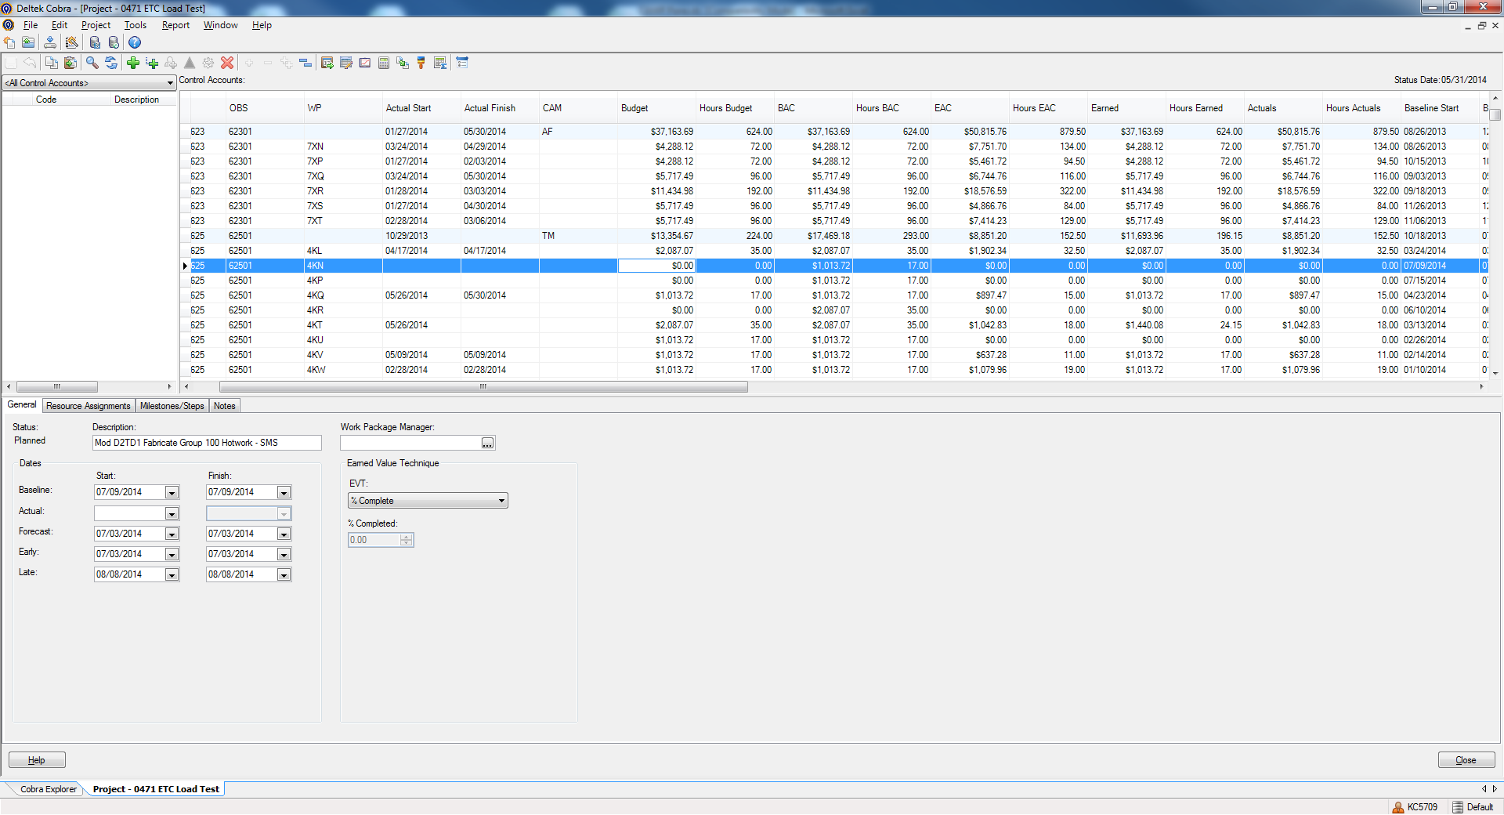

1. Copy the CAWP Pane (Edit>Copy CAWP Pane). Open this file and copy the worksheet to a blank worksheet in the **Status file**.
2. In the **Status file**, perform a vLookup to the worksheet you copied the CAWP data into to bring in the Actual Start Date and Actual Finish Date. There should be no Finish Dates. If you are closing a Work Package, enter a date within the reporting period as the Actual Finish Date. Ensure that if a Work Package is statused to 100%, it has a Finish Date and vice versa. Save and close this file
3. In Cobra, start the Integration Wizard. Select Project Data. Click Next.
4. Select the radio button to Open and existing configuration. Navigate to and select your Material Status load file. Click Next.
5. Check the box for Status. Click Next.
6. Click the ellipsis for Status File, navigate to and select the Status file you just created.
7. Select your project. Click Next.
8. The field mapper should already be set with the order of the fields in the Status File. Click Next.
9. On the Status screen, click the dropdown for **Update status using** and select **Early Dates.** Nothing else is checked on this screen. Click Next.

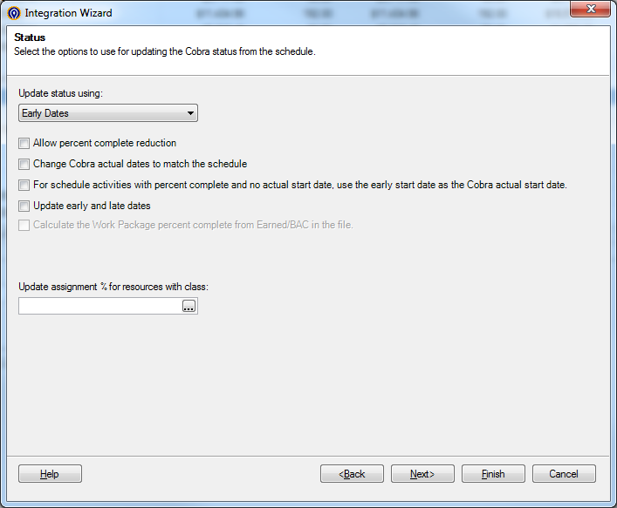

1. On the filter screen, select Work Package as the criteria and select all the Work Packages for the selection. Click Next.

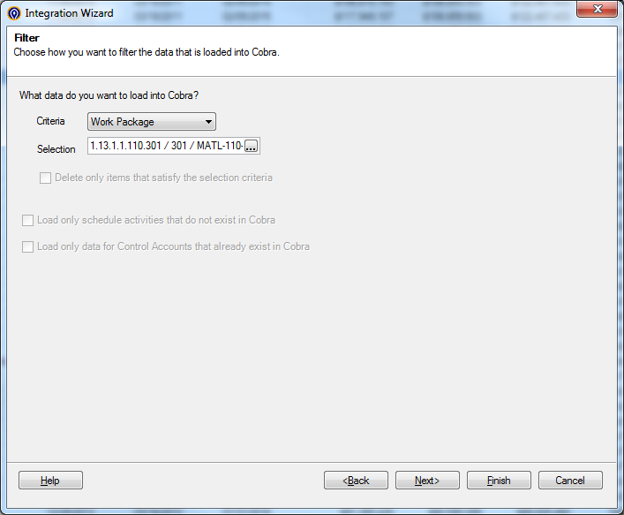

1. Save if you want, otherwise click Finish.
2. Calculate Earned Value